One Click Installation

Ports

To run application on website. ports are:

* Hadoop: 9870 // Example: 20.219.96.132 is ip address and 9870 is port number.
* Spark: 8080 // Example: 20.219.96.132 is ip address and 8080 is port number.
* Airflow: 8181 // Example: 20.219.96.132 is ip address and 8181 is port number.
* Hive: 10002 // Example: 20.219.96.132 is ip address and 10002 is port number.
* Postgres: 5432 // Example: 20.219.96.132 is ip address and 5432 is port number.
* MySQL: 3306 // Example: 20.219.96.132 is ip address and 3306 is port number.
* Mongo dB: 27017 // Example: 20.219.96.132 is ip address and 27017 is port number.
* MSSQL: 1433 // Example: 20.219.96.132 is ip address and 1433 is port number.

Installation

**Note:**

Start script by configuring slave server and then on master server because if you install master first then all the services will be up in run without slave server being configure.

**Step1:**

Add the script into the server by using cmd

1: sudo nano script.sh

2. Add the script into the script.sh and close the file.

3. Run the script using cmd: bash script.sh

**Step2**:

While running this script you will encounter SSH where SSH required an input i.e.

It requires password to process to next line. So password is: Shelby51035252

This done because with helps of this connection between master and slave server.

It will help us to transfer data from one server to another or vice versa.

**Note:**

There will be few cases where you will get stuck after entering the password just press “q” from keyboard. It will process to next line and installation will start.

**Note:**

If you want to install mysql and mssql then follow the step3 and step4 otherwise skip to step5.

**Step3:**

While installing MySQL you will encounter some inputs like.

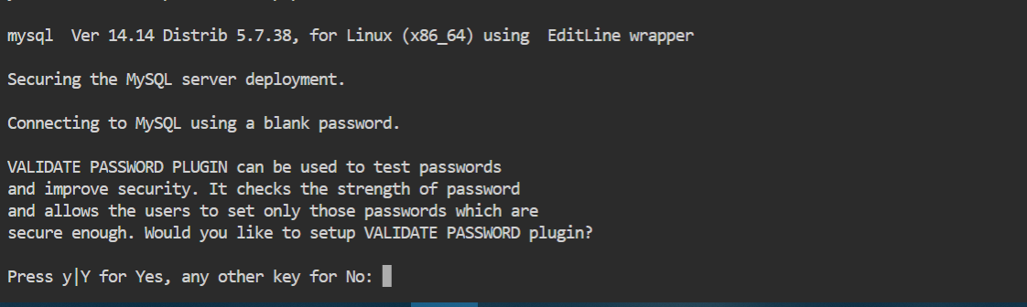

In this type ‘y’ to validate password plugin. It helps to test passwords and improve security.

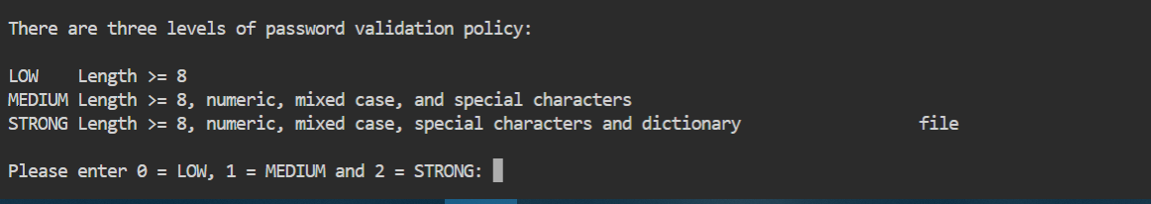

In this it will ask for level of password security that range from 0 to 2 i.e. week to strong choose according to your requirement.

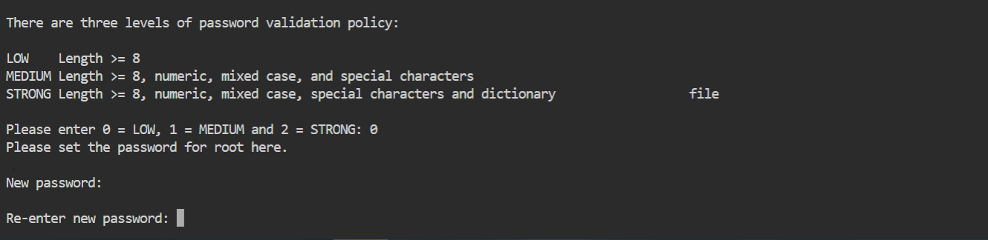

After selecting the level of password enter your password according to the criteria and then re-enter the same password.

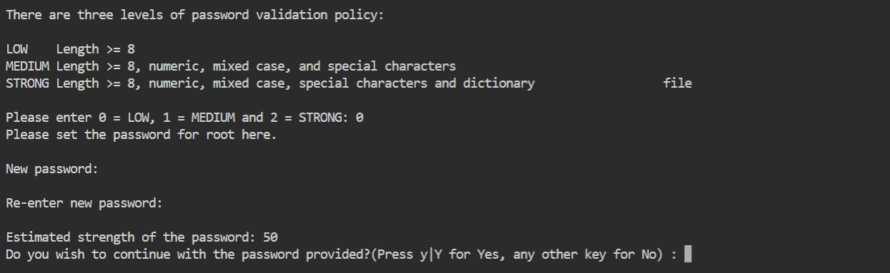

Type ‘y’ to continue with same password or type ‘n’ to reset the password.

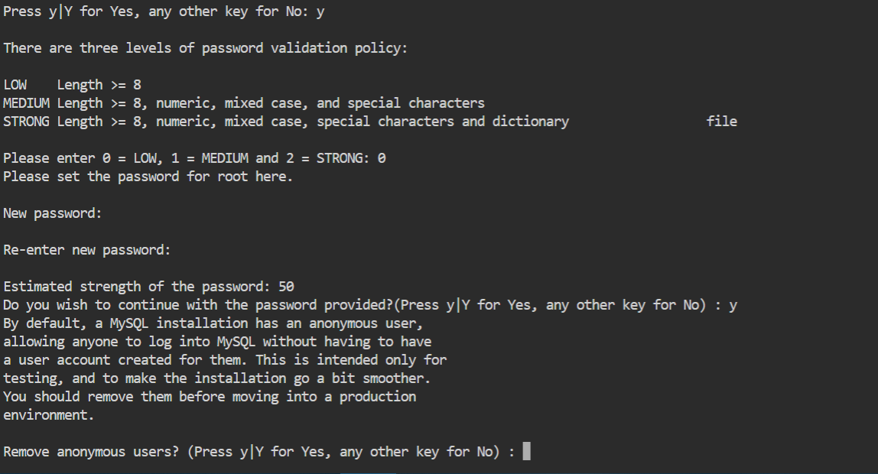

After entering the password it will ask to remove anonymous users from MySQL type ‘y’ or ‘n’ according to your requirement.

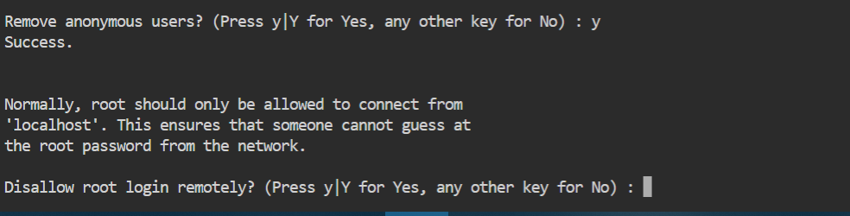

In this step it will ask to disallow root login remotely type ‘y’ or ‘n’ accordingly .this will help in security purpose.

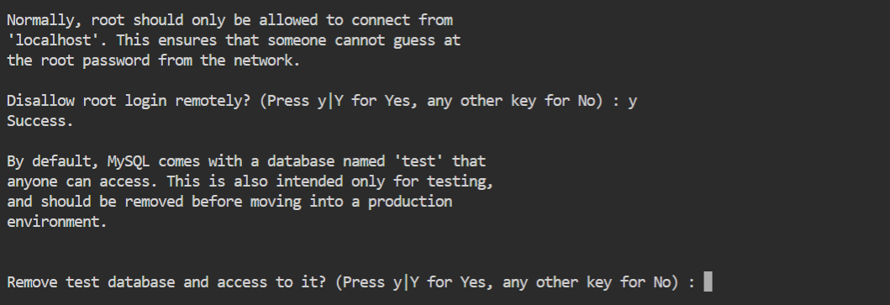

In this step it will ask for remove test database and its access type ‘y’ or ‘n’ accordingly.

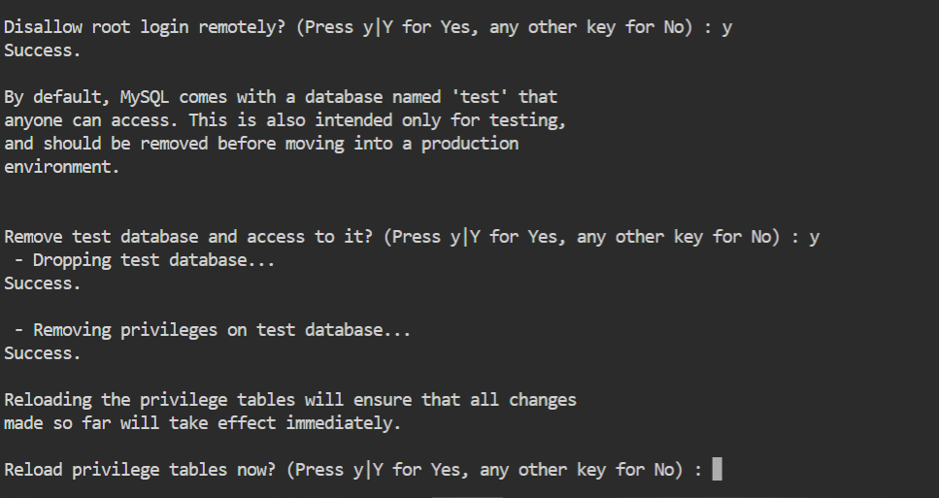

In this step it will ask for Reload privilege tables in MySQL type ‘y’ or ‘n’ accordingly. it will help to ensure that all changes will be effected immediately.

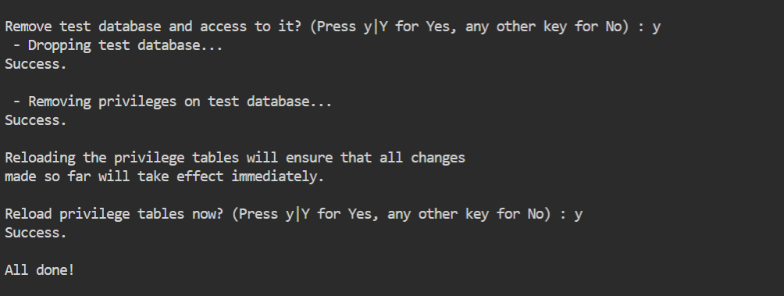

After following all the steps we have install MySQL successfully to check if it’s installed in your system type: sudo mysql

**Step4**:

While installing mssql you will encounter some inputs like.

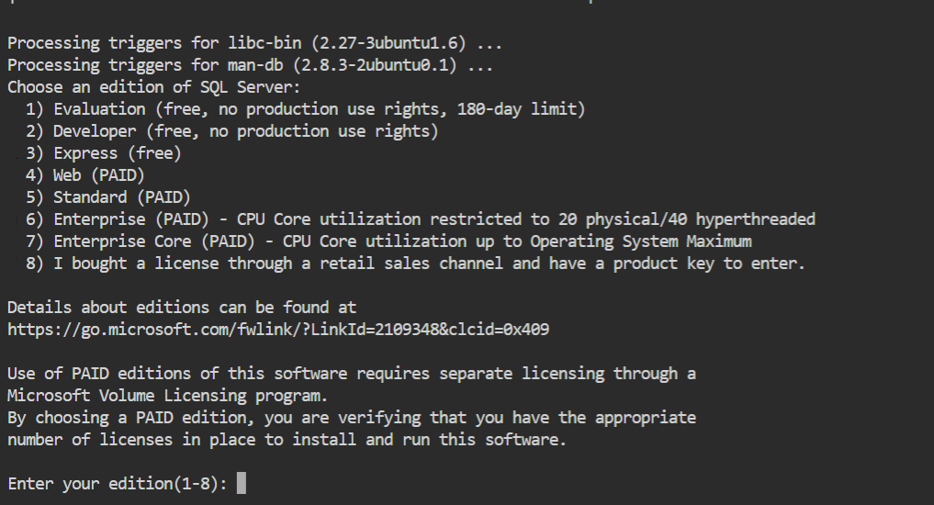

In this it is asking about which server edition you want to install from (1-8) and we are using developer edition so type 2.

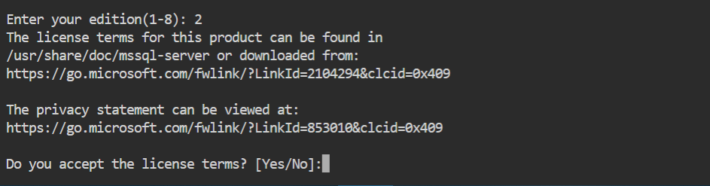

Accept the license terms by typing ‘Yes’.

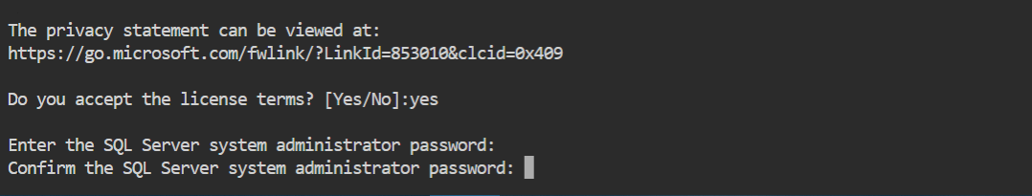

Enter your password and re-entering the same password according to your choice.

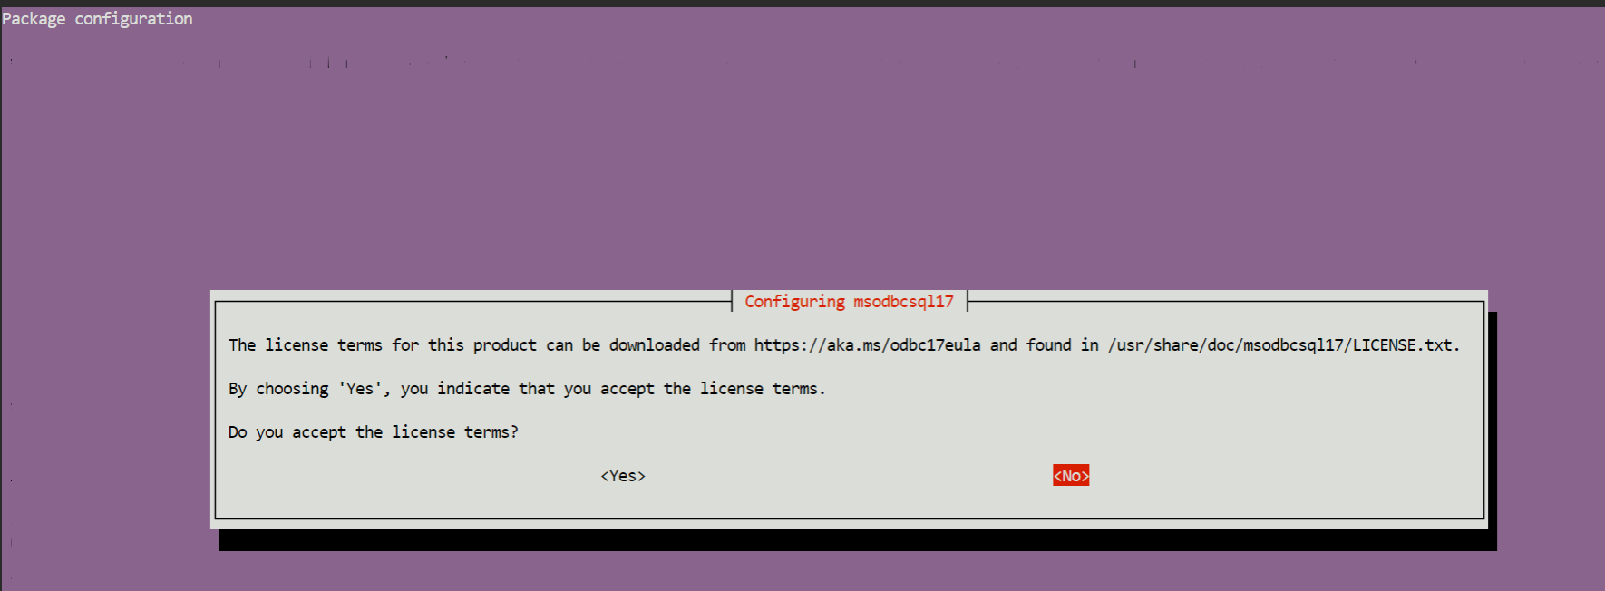

Accept the license terms by selecting <yes>.

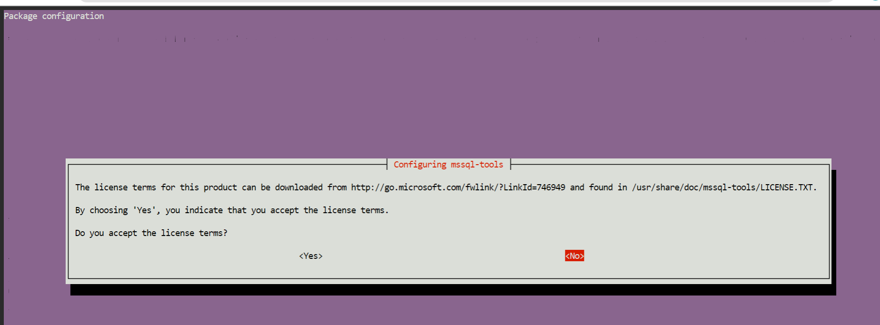

Accept the license terms by selecting <yes>.

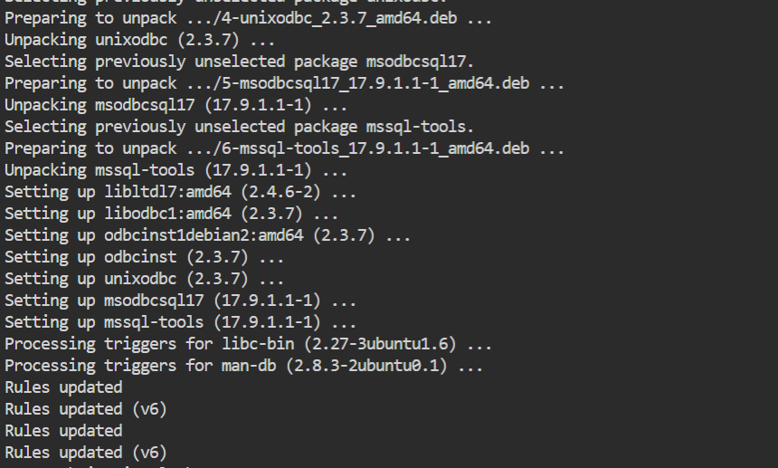

After accepting the licences we have installed mssql server into our system.

**Step5:**

After installation it will ask to press [Enter].



In this press Enter to continue. This done because with helps of this, connection between master and slave server will help us to transfer data from one server to another or vice versa.

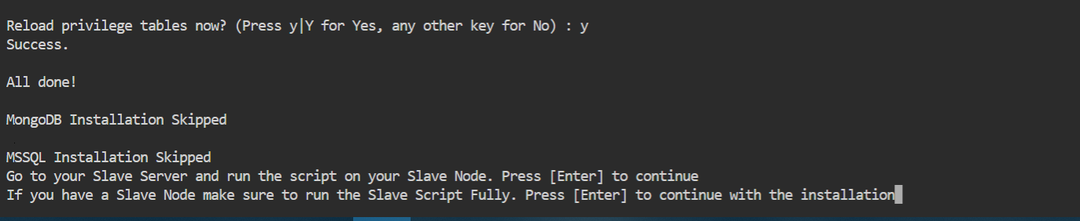

Again it will ask to press [enter].this done to ensure that our slave server is fully running and we are ready to continue [i.e. master server] the installation and start up all the services which are installed.